BUSINESS PLAN 2021-22

**DRAFTING NOTES**

This draft is current for the date shown below. It is, however, written ‘as at’ 1/4/2021.

The draft reflects SIB’s current understanding of the Executive’s intentions for the Programme for Government and the Investment Strategy. Certain key elements of the plan (e.g. an approved Letter of Expectation, an approved AMU plan, a confirmed budget) are unlikely to be available before April 2020.

Material to be updated is shown **[thus]**.

Author: Brett Hannam

Status: DRAFT v0.3

Date: 12/3/21

Contents

Foreword 1

Responsibilities 2

People 4

Resources 5

Governance 6

Delivery Partners 6

Priorities 7

Delivery 8

Measuring Progress 9

Appendix 1: Activities in 2020-21 10

Appendix 2: Organisation Chart 14

Appendix 3: 2020-2021 Budget 15

Appendix 4: Letter of Expectation 16

Appendix 5: The SIB Board 20

Appendix 6: The Corporate Plan 21

Appendix 7: SIB Objectives for 2021-22 26

# Foreword

## Operating Highlights

2020-21 has been dominated by the Covid19 pandemic and I introduce this plan by thanking SIB’s staff for their energy, flexibility and resilience in responding to the challenges arising from the virus. Our partners sought assistance in areas as varied as epidemiological data analysis, the identification of warehousing, the establishment of crisis command centres and the provision of volunteer drivers. I am pleased to report that in each case, and others, SIB was able to provide the support requested.

SIB has continued to deliver programmes and projects that were underway before the pandemic and to develop new areas of work. Highlights of the last 12 months include the award of the contract for Project Stratum (Ultrafast Broadband), the development of the regional Energy Strategy, the completion of the Armagh and Banbridge campuses of Southern Regional College and the opening of the South Lakes Leisure centre in Craigavon. New areas of work include ‘Green Growth’, the regional housing strategy and an extension to the role of the Social Value unit. SIB has, as in previous years, worked with every government department and a majority of councils.

The specific contributions we have made to the success of our partners during 2020-21 are recorded in Appendix 1.

## Looking Ahead

As the government transitions from managing a health emergency to driving forward economic recovery, SIB is well-placed to assist its partners in their important work. SIB drafted the new Investment Strategy (ISNI), which sets out the Executive’s ambitions for the use of its capital budget over the next ten years and beyond. These plans address both the short-term need to provide an immediate stimulus to commercial activity and the long-term requirement to address the generational challenges of climate change, an ageing population and new technology. Delivering the ISNI will contribute to the achievement of the outcomes defined in the Programme for Government and make a significant contribution to improving wellbeing for all by tackling disadvantage and driving economic growth.

After seven years as Chair of the Board, this is the last business plan that I will present on behalf of SIB. I am confident that the ambitious targets it sets are within our capacity and capability to deliver. I wish our partners, our staff and my colleagues on the Board every success and thank them for their dedication and hard work.

Gerry McGinn  
Chair

April 1, 2021

# Context

This plan has been drafted in the context of the COVID pandemic. The measures taken to reduce the spread of the virus have had an unparalleled adverse economic impact on the region, leading to higher unemployment, lower wages, reduced growth and impaired productivity. Particular sectors, such as retail, the arts, tourism and hospitality and specific groups such as young people and some self-employed have suffered disproportionately. Government revenues have fallen while expenditure has risen.

More positively, the shift to remote working has accelerated and it has been demonstrated that many employees can work effectively from home for much of the time. This has improved the quality of life for some commuters and contributed to reduced traffic levels and better air quality.

The pandemic has emphasised the importance of digital connectivity and demonstrated the need for citizens to possess digital skills and access if they are to participate fully in an increasingly digital society.

As the region emerges from lockdown, government will seek to stimulate economic recovery and promote employment. It will also need to address the trade frictions arising from the implementation of the NI Protocol of the Brexit agreement. In the short term at least, the requirements for additional documentation arising from the region’s unique status within the EU and UK will increase some business costs. In the longer term, that status offers unique business opportunities.

The long-term challenges the region faced before Brexit and the pandemic, most notably its relatively low productivity, sub-regional imbalances and unreformed health and education remain. To these should be added the generational issues arising from climate, demographic and technological change.

Taken together, these factors create an operating context characterised by uncertainty, resource pressures and political demands for rapid responses and change.

# Responsibilities

The Strategic Investment and Regeneration of Sites (Northern Ireland) Order 2003 established Strategic Investment Board Ltd (SIB). The legislation sets out the functions of SIB as being:

(1) **To advise the Executive in relation to the formulation and implementation of its programme of major investment projects.** SIB achieves this primarily through the production of the region’s Investment Strategy (ISNI). The ISNI is a rolling ten-year plan that sets out the Executive’s capital investment plans. The scope of the ISNI encompasses almost every area of government including education, health, and transport and is the expression of the priorities of Ministers in the Executive Committee of the Northern Ireland Assembly, (‘the Executive’). In doing so, the ISNI complements the Executive’s Programme for Government (PfG) and Budget. SIB also publishes a pipeline of government projects and manages the ISNI Delivery Tracking System (DTS) to keep supplier markets and other stakeholders informed of the Executive’s future infrastructure development plans.

(2) **To advise bodies carrying out major investment projects on the delivery of such projects**, by providing research, consultancy, advisory and other services and general assistance. Such assistance includes advising on and assisting with the planning, prioritisation and funding of programmes and projects and their implementation. SIB discharges this responsibility in several ways. We provide staff to fill senior project management and advisory roles in support of the partner organisations that are leading the delivery of these projects. We complete short-term assignments in a manner analogous to management consultants and we provide ‘common good’ services in areas such as communications, procurement law and specialist recruitment.

Ministers have also determined that SIB should establish and operate discrete units within SIB to lead work in specialist areas. These units are currently:

(a) **The Asset Management Unit.** The AMU developed, and now co-ordinates the delivery of, the Executive’s Asset Management Strategy (AMS). This promotes the effective and efficient management of Central Government’s property assets. The AMU is responsible for ensuring the successful delivery of this AMS. The AMU also supports the deployment of the Executive’s allocation of Financial Transactions Capital and promotes, through the Energy Management Strategy, the public sector’s efficient use of energy.

(b)**The Social Value Unit** (previously known as the Buy Social Unit). The Social Value Unit works across government to improve the social return on government procurement and investment, by – for example – using social clauses in government contracts to promote the provision of job opportunities to hard-to-reach groups.

(c) **The Data Analysis, Research and Evaluation Unit (DARE)**. The DARE provides data and systems modelling support across government. It advises on the use of advanced statistical modelling (including machine learning and artificial intelligence techniques) to extract maximum value from public sector data, particularly for forecasting and rapid scenario evaluation. It uses Systems Dynamics Modelling to understand and model complexity in large and inter-related public sector systems.

(d) **Digital Catapult NI** (DCNI). Operated on behalf of the Department for the Economy, DCNI helps local organisations of all sizes to originate and adopt advanced digital technologies for commercial benefit.

(e) **The Council Support Unit**, which provides project management services to local councils and also informs strategic planning for waste management.

(f) **The Strategic Support Unit**, which provides short-term, focussed support to partners in areas such as programme and project assessment, business case development and technical analysis.

The purpose of the Northern Ireland Programme for Government (PfG) is to improve wellbeing for all by tackling disadvantage and driving economic growth. Our work contributes to the successful achievement of this objective by enabling our partner organisations in the public sector to achieve their PfG outcomes and indicators. The linkages between these and the work of SIB are set out in ‘Section 4: Delivery’ below.

# People

SIB employs some 125 staff who are organised in groups and teams. Its structure comprises five lines of business:

* **Strategic Advice**: which provides specialist technical, legal, research, procurement and communications support to partner organisations;
* **Physical Infrastructure**: which manages regionally significant capital projects for departments and councils;
* **Asset Management**: which advises the public sector on the effective and efficient use of public assets and promotes the reform of property management;
* **Digital Infrastructure**: which contains the Data Analytics, Research and Exploitation Unit, the NI Digital Catapult and staff managing digital projects; and
* **Social Infrastructure**: which contains teams working on Buy Social, Urban Villages and Social Investment.

In addition, there is a corporate services team comprising support staff working in finance, HR, information and compliance, communications and the provision of legal advice.

An organisation chart, showing SIB’s structure and staff currently in post can be found at Appendix 2.

# Resources

SIB receives grant-in-aid funding from TEO and recharges partner organisations in respect of the salaries of its staff where these posts are funded by the partner. The sources and applications of these funds are shown below and more detailed information is in Appendix 3.

|  |  |  |  |  |  |  |  |  |  |  |  |  |  |  |  |
| --- | --- | --- | --- | --- | --- | --- | --- | --- | --- | --- | --- | --- | --- | --- | --- |
| |  |  | | --- | --- | | **Income** |  | |  |  | | Grant in Aid from TEO | £4,834,000 | | Technical Transfers from NICS Departments | £987,000 | | Salary Recharges | £6,521,854 | | Other Ring-Fenced Income | £751,000 | | **Total Income:** | **£13,093,854** | |  |
| |  |  | | --- | --- | | **Application of Funds** |  | |  |  | | Salaries | £10,815,229 | | Enabling Expenditure | £1,525,625 | | Operational Costs | £753,000 | | **Total Expenditure** | **£13,093,854** | |  |

# Governance

SIB is a company limited by guarantee. It is owned by the Executive Office (TEO) and financed from within TEO’s departmental expenditure limit. The Board of SIB is accountable, through its Chair, to the First Minister and deputy First Minister who set its priorities. These are expressed in an annual ‘Ministerial Letter of Expectations’. A copy of the latest of these letters is contained in Appendix 4.

SIB is a part of the public sector, but our staff are not civil servants and are employed on different terms and conditions.

The Board has overall responsibility for setting and monitoring strategy, for developing and implementing policy and for supervising risk management, budgetary control and business planning. A list of members of the Board is attached at Appendix 5.

The Board operates two committees: the Audit Committee, which provides assurance to TEO, as shareholder, that our financial and other control systems are operating effectively; and the Remuneration and Personnel Committee, which endorses senior appointments and salaries, scrutinizes recruitment and the payment of allowances and which oversees organisational development.

The Chief Executive is SIB’s Accounting Officer. He directs the work of SIB and manages its day-to-day operations.

# Delivery Partners

SIB works with organisations across the entire public sector, including government departments, councils and arms’ length bodies.

SIB has no powers of direction and may only work at the request of the organisations we support.

# Priorities

SIB’s vision is that Northern Ireland will build and sustain a public social and physical infrastructure fit for the needs of all its people.

Our long-term organisational goal is that we continue to have the capacity and capability to respond to discharge the responsibilities set out in our establishing legislation.

Our Corporate Plan is set out at Appendix 6. This sets out our medium-term strategic priorities, objectives and outcomes for the period 2021-23. It also describes our operating strategy and our annual demand assessment exercise.

SIB’s priority work for the year 2021-22 will be:

* To assist government address the challenges arising from the Covid-19 pandemic;
* To continue to deliver, to time and budget, the programmes, projects and assignments that we lead and support;
* To deliver cash savings through improving the efficient use of government assets, including reductions in the use and cost of energy;
* To improve the quality of public-sector investment decision-making through original research and the innovative analysis and exploitation of data;
* To improve the social return on public procurement by extending the use of ‘Social Value’ models;
* The development of new approaches to the development and management of Financial Transaction Capital (FTC) loans and investments;
* To support the development of new models for social housing;
* To support the development and implementation of the region’s ‘Green Growth’ strategy;
* The extension of support to regeneration programmes and projects; and
* To monitor and review the implementation of SIB’s new organisational structure.

# Delivery

Appendix 7 contains our work plan for the year 2021-22. This sets objectives for each of our major programmes, projects and functional areas. It describes our targets and actions, the contribution these will make to specific PfG outcomes and identifies the staff responsible for their achievement.

[**DN: Check status at approval date:** This plan has been drafted during the Covid-19 pandemic, at a time when government’s future requirements of SIB are unclear. This plan is therefore presented on a ‘business-as-usual’ basis, on the understanding that it will change and evolve over the coming year in response to new and amended demands. The Board and CEO will be responsive to such changes and agile in addressing them.]

SIB pursues four types of objective. These are listed below and identified in the list of objectives by the relevant acronym.

a) Targets related to regionally significant projects (RSP);

b) Targets that support or enable the achievement of other objectives or targets such as, for example, the development of Strategic Infrastructure Planning Models, revenue efficiencies and capital realizations (E);

c) Targets related to corporate governance and administration (G).

d) Targets related to the establishment and maintenance of capabilities such as, for example, the Strategic Support Unit, which completes short-term specialist assignments (C).

Targets in category (e) do not have specific milestones attached to them. However, specific operational targets for these teams will arise during the year.

To keep the number of targets manageable, not every SIB-supported activity has a target included in this business plan.

The AMU has a separate work plan that is approved by the Asset Management Programme Board. This plan is attached at Appendix 7.

# Measuring Progress

SIB operates within a performance management framework that is consistent with the FABRIC[1] approach to performance information. It includes the following elements:

* Annual assessment of the benefits and achievements SIB has delivered;
* Assessments of delivery against the Ministerial Letter of Expectations;
* Monthly assessments of the ongoing deliverability of Business Plan outcomes;
* Quarterly reporting of progress with the implementation of this Business Plan;
* Quarterly reports on all Programmes, Projects and activities undertaken by SIB;
* Immediate exception reporting should the successful achievability of desired outcomes be doubted;
* Feedback on all assignments undertaken by the Strategic Support Unit;
* Feedback from partner organisations on outcomes and the performance individual embedded SIB staff;
* Periodic independent, organisational reviews.

# Appendix 1: Activities in 2020-21

During 2020-21, the Strategic Investment Board:

* Provided Directors or Managers for the following programmes and projects:
  + Strule Education Campus;
  + NI Fire & Rescue Service (NIFRS) Training College at Desertcreat;
  + Casement Park (GAA);
  + The Urban Villages programme;
  + Social Investment Fund capital and revenue projects;
  + Department of Finance Agile Working project;
  + Arc21 Waste Management procurement;
  + Southern Regional College Campus programme
  + Northern Regional College Campus programme
  + Ebrington capital projects;
  + North Coast Sports Village;
  + Public Sector Shared Network project;
  + Ultrafast Broadband (Project Stratum);
  + South Lakes Leisure Centre;
  + Mobuoy Road Remediation Project;
  + Newry Civic Centre project;
  + The ‘Shop Local’ project;
  + United Youth programme; and the
  + Tackling Paramilitarism programme.
* Provided data analytical support to departments and ALBs;
* Completed 125 assignments through the Strategic Support Unit; and
* Managed the Investment Strategy Northern Ireland Delivery Tracking System and project pipeline.

During the Covid-19 emergency SIB:

* Provided data-analytical support to the Department of Health and Health Trusts;
* Led the Digital Coordination Cell for the Health and Social Care response to the pandemic (including overseeing the development of the StopCOVID19 app);
* Established a Project Management Office (PMO) to oversee the work of consultancy firms assisting the NICS establish the NI Hub, its command and control centre for managing government’s response to the Covid-19 emergency;
* Provided three members of staff to fill Deputy Chief of Staff roles within the Hub;
* Filled the role of functional lead for Communications within the Hub;
* Operated a PMO within the NI Fire and Rescue Service to establish and operate a Gold Command;
* Identified and procured additional warehousing for Health and Social Care;
* Devised and operated the Waste Tracker system and Volunteer Waste Driver systems for SOLACE and local councils;
* Advised on recruitment to the Covid19 Task Force; and
* Managed the ‘Shop Local’ High Street Support project.

With support from our partners we:

* Provided, through the Buy Social initiative, 6,136 person weeks of employment to 266 people who were long term unemployed or had no substantial work experience;
* Obtained £9.5m through capital realisations bringing the total realised since 2012 to £240.5m;; and
* Managed £175m of loans of Financial Transactions Capital.

Specifically, the Strategic Investment Board:

* Supported **The Executive Office** by:
  + providing the acting Chief Executive for the MLK Development Corporation;
  + providing a team to work on the Urban Villages programme;
  + providing project managers to the Social Investment Fund capital and revenue programmes;
  + providing a director and project managers to deliver capital projects, strategic planning and asset disposals at Ebrington; and
  + reviewing existing PPP/PFI contracts.
* Supported the **Department of Agriculture, Environment & Rural Affairs** by:
  + providing a Director for the Green Growth Programme;
  + providing a project manager for the arc21 residual waste management infrastructure project;
  + providing a Strategic Adviser to support work on investment in fisheries;
  + providing strategic advice on waste management;
  + providing a Project Director for the Mobuoy Road Project; and
  + leading work on the Circular Economy.
* Supported the **Department for the Economy** by:
  + Establishing and staffing the Digital Catapult NI and Immersive Laboratory;
  + seconding a strategic adviser to run the Department’s Energy Directorate;;
  + implementing the Energy Management programme;
  + providing a project manager for the United Youth project;
  + providing a Chief Digital Officer to TNI;
  + providing a Vice-Principal Organisational development to Northern Regional College;
  + providing a project director for the Ultrafast Broadband project (Project Stratum);
  + providing project managers for the Southern and Northern Regional Colleges capital investment programmes;
  + advising on the management of the Department’s Further Education investment programme;
  + advising on the Department’s support to Ulster University’s Graduate Entry Medical School and Belfast Campus Project;
  + administering of the Department’s £175m Financial Transaction Capital loan portfolio and providing ongoing due diligence;
  + advising on the promotion of the role of Hydrogen in decarbonisation and renewable energy generation;
  + providing programme management for £2.4m Data/Digital SBRI Innovation Fund;
  + supporting InterTradeIreland’s transition to a data led organisation through a review of data systems, processes and infrastructure; and
  + Providing a Project Manager and delivery team for the High Street Support Scheme.
* Supported the **Department for Communities** by:
  + providing the GAA with a project manager for Casement Park;
  + providing an embedded team to advise the Engaged Communities group on infrastructure planning and delivery;
  + advising on the development of a Housing Strategy;
  + providing a Capital Programme Director to National Museums, NI;
  + providing project management support to Historic Environment Division;
  + providing advice on extension of the Personal Independence Payment (PIP) contract.
  + developing a new risk management system for the Charity Commission for NI; and;
  + providing advice to Armagh Observatory and Planetarium, the Arts Council and Ulster Orchestra.
* Supported the **Department of Education** by:
  + providing a construction manager and leading the communications function for the Strule Educational Campus programme; and
  + providing data analytical support to the department’s schools and transport planners.
* Supported the **Department of Finance** by:
  + operating the Asset Management Unit;
  + providing a Transformation Director and staff for the Agile Working programme;
  + providing a project manager for the Public Sector Shared Network project;
  + devising and implementing the Energy Management Strategy;
  + Advising on the recruitment of the interim Head of the Civil Service; and
  + operating the ‘Buy Social’ unit to promote the delivery of social value in public sector procurement.
* Supported the **Department of Health** by:
  + providing a project manager for the NIFRS College at Desertcreat;
  + providing a Chief Digital Officer for Health and Social Care;
  + providing data analytical and dynamic systems modelling support;
  + advising on a programme of revenue funded investment in primary health care facilities (including the preparation of business cases; the conduct of bidder negotiations and the provision of legal advice);
  + advising on the reform of GP Out of Hours services; and
  + advising on the development of the 111 and National Pandemic Flu service.

* Supported the **Department for Infrastructure** by:
  + providing an Organisational Development Director to DVA; and
  + advising on the regeneration element of the Weavers Cross project.
* Assisted the **Department of Justice** by:
  + provision of a Programme Director and research analyst to the Tackling Paramilitary Activity Programme;
  + provision of a data modelling and scenario evaluation tool and the development of visualizations for the Committal Reform project;
  + development of a Strategic Decision Support System for the NI Courts and Tribunal Service (NICTS);
  + development of the NI Courts Transformation Planning System;
  + provision of advice on the development of the DoJ Digital Strategy;
  + provision of advice to the Courts Service on Transformation, Estates and Communications;
  + provision of an embedded Technical Advisor on Historic Enquiries;
  + provision of Estates Planning advice to PSNI; and
  + support to the Office of the Prisoner Ombudsman.
* Supported **Belfast City Council**, **Derry City and Strabane District Council, Ulster University** and **Queen’s University, Belfast** by advising on City Deal projects.
* Supported **Belfast City Council** through the deployment of its Digital Commissioner;
* Supported **Derry City and Strabane District Council** through:
  + the provision of a property advisor;
  + management of the Community Centres Capital programme; and
  + the development of Foyle Street regeneration proposals.
* Supported **Armagh, Banbridge and Craigavon Council** by providing a project director for the South Lake Leisure Centre and Armagh Leisure Village.
* Supported **Newry, Mourne and Down District Council** by the provision of a project manager and the procurement of a development partner for the Newry Civic Centre project.
* Supported **Causeway Coast and Glens Council** by the provision of a project manager.
* Supported **Ards and North Down Borough Council** by the provision of a Head of Strategic Capital Development.
* Supported **Mid and East Antrim Council** through:
  + the provision of a project manager; and
  + the provision of a property advisor.
* Supported other councils by providing strategic, communications and other advice.
* Provided 2,295 days of support on 125 assignments to departments and councils through the deployment of staff from the Strategic Support Unit; and
* Supported departments and other organisations through the provision of advice on procurement law, recruitment and communications.

# Appendix 2: Organisation Chart



# Appendix 3: 2021-2022 Budget



# Appendix 4: Letter of Expectation

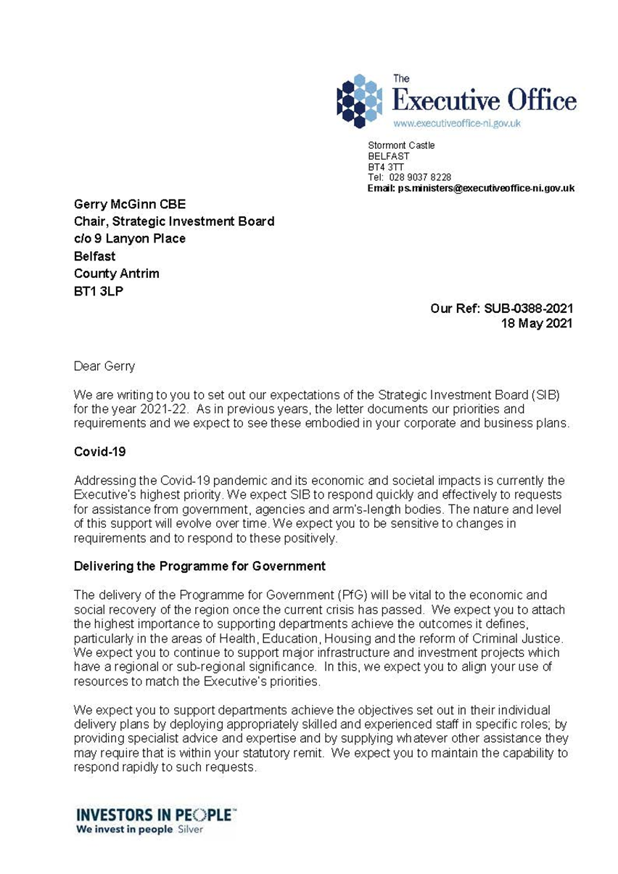

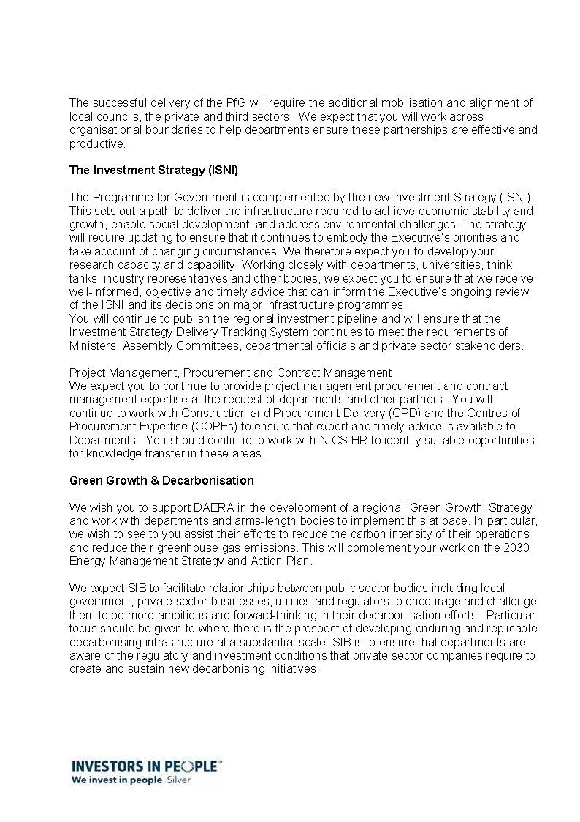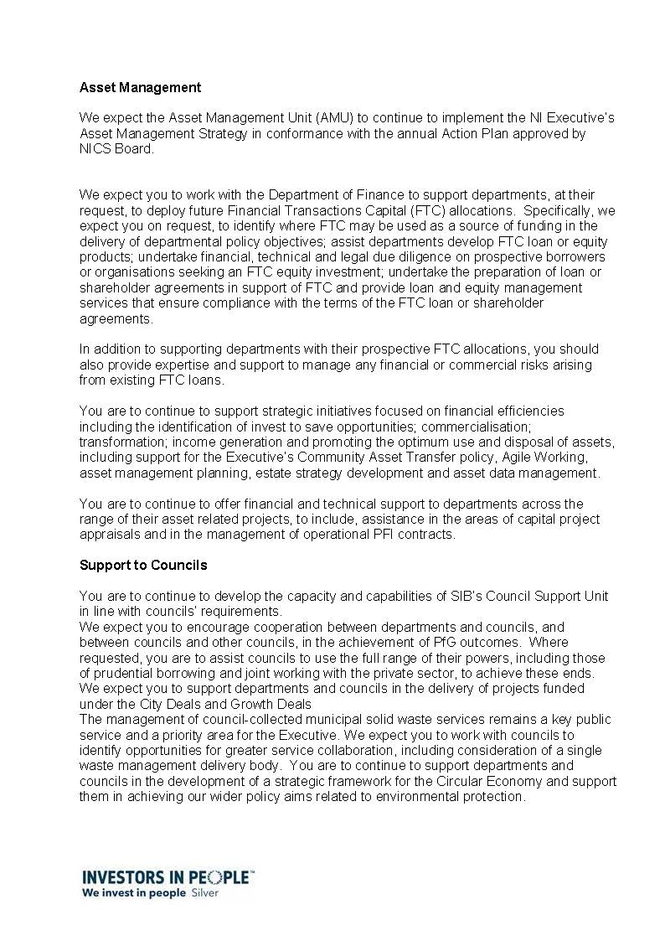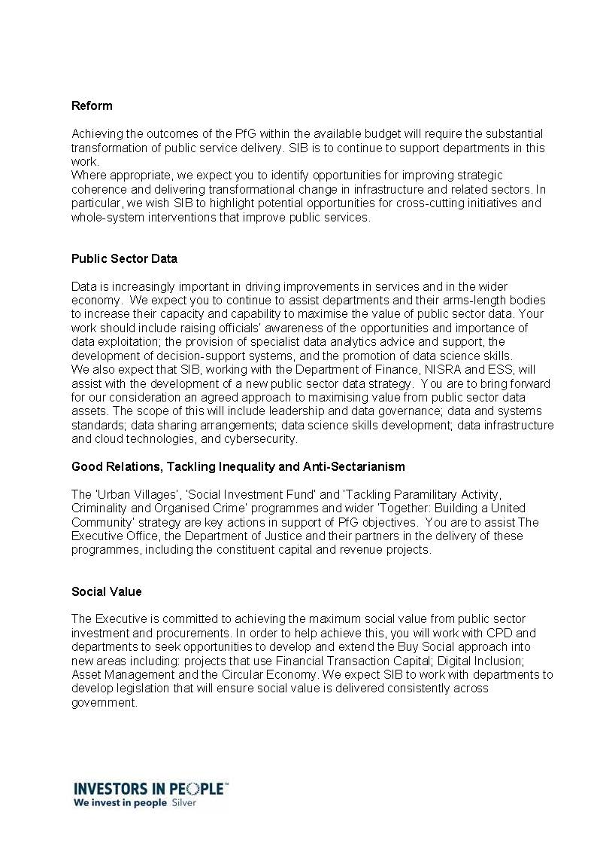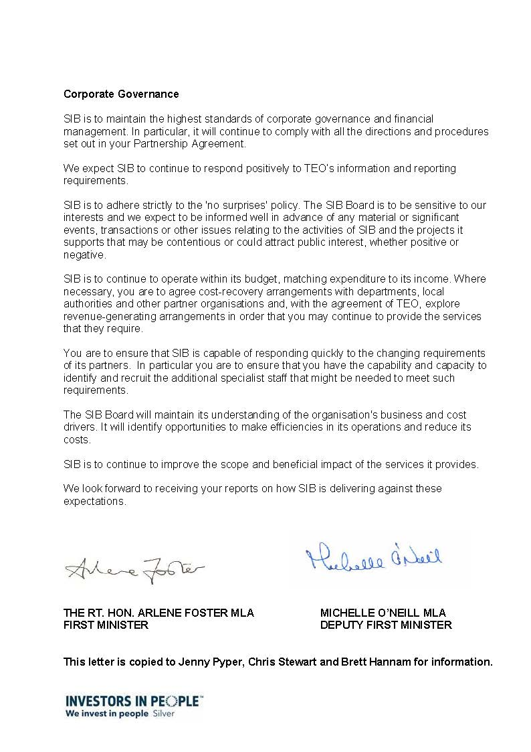

# Appendix 5: The SIB Board

|  |  |  |
| --- | --- | --- |
| Mr Gerry McGinn | Chairman | (since September 2013) |
| Mr Duncan McCausland | Non-Executive Director | (since September 2013) |
| Ms. Kathryn Thomson | Non-Executive Director | (since September 2015) |
| Ms. Marie-Thérèse McGivern | Non-Executive Director | (since September 2013) |
| Mr Danny McSorley | Non-Executive Director | (since November 2015) |
| Mr Brett Hannam | CEO & Executive Director | (since January 2006) |

# Appendix 6: The Corporate Plan

## Strategic Priorities

SIB derives its strategic priorities from the outcomes defined in the draft Programme for Government (PfG) Outcomes Framework. All SIB’s work will contribute to the achievement of these outcomes.

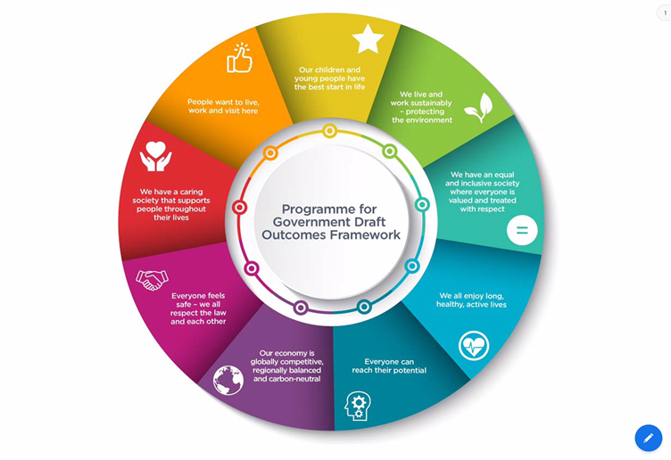

In line with the draft PfG, the over-arching priority for SIB is “improving wellbeing for all – by tackling disadvantage and driving economic growth.”

The priority issues SIB will address are:

* the statutory requirement for SIB to advise the Executive in relation to its investments;
* the statutory requirement for SIB to advise public bodies on the delivery of major investment projects;
* the need to deliver those projects to the required quality, on time and within budget;
* the need to obtain value for money for infrastructure investment (including the delivery of social value through sustainable procurements and use of assets);
* the need to make best use of existing assets and dispose of those that are surplus to requirements;
* the need to engage with the private sector more closely in order to optimise the use of private funding in support of public investment, (while recognising that private funds do not have general applicability at all times or across all types of infrastructure);
* the need to deliver the best possible return to the Executive through the use of Financial Transactions Capital (FTC);
* the need to support strategic infrastructure planning;
* the need to address the generational challenges of climate, demographic and technological change;
* the need to improve the infrastructure delivery capabilities of government departments;
* the need for continual improvement in the processes and procedures for the commissioning, procurement and operational management of major capital investments;
* the need to develop SIB’s capacity and capabilities to ensure it continues to meet the needs of its partners;
* the need to be flexible and informed to support departments in the delivery of new major investment policies and programmes;
* the need to engage effectively with all SIB’s stakeholders;
* the need to improve the infrastructure delivery capabilities of local government (district councils); and
* the need to work with councils to make best use of their existing assets in line with their Corporate and Community Plans.

## SIB Medium Term Objectives, Outcomes and Targets

The medium-term objectives derived from the strategic priorities are:

* to support investment planning through the provision of analytical support and advice; strategic infrastructure planning models and advice on project finance and the use of FTC (including the operation of the NI Investment Fund);
* to deliver supported projects and programmes in accordance with the plans set out in the Investment Strategy and the principles of economic, social and environmental investment and sustainability;
* to seek effective ways to accelerate the investment timetable without compromising good governance or value for money;
* to meet the targets for additional revenue and capital realisations from property assets;
* to support departments and other public bodies in the efficient and effective management and operation of their estate;
* to identify socially valuable uses for surplus assets that cannot for the present be sold or otherwise exploited;
* to support departments and councils in the development of strategies for the commercial exploitation of their assets;
* to foster and promote reform both in the delivery of major public sector infrastructure and as a pre-requisite for such investment;
* to work with departments, councils and other relevant bodies to ensure that their infrastructure plans are aligned and, where appropriate, that these plans are also aligned with both those in the Republic of Ireland, in accordance with North/South agreements, and also arrangements for East/West co-operative working (e.g. the Infrastructure Commission and the Infrastructure and Projects Authority);
* to develop close working relationships with stakeholders in the private and third sectors; and
* to develop the organisation and the individuals within the organisation.

The indicators of success for these objectives will be that, by the end of the period covered by this plan:

* SIB has delivered strategic infrastructure planning models in key sectors, which help its partners to plan and deliver more economically and operationally sustainable infrastructure to meet citizens’ contemporary and future needs across the region;
* SIB has helped partner organisations deliver larger and better project procurements (in terms of faster delivery, lower risk and best value) than would otherwise have been possible, so maximizing the return on available capital budgets;
* SIB has helped departments develop their infrastructure programme and project delivery capability so that projects and programmes can be delivered efficiently, effectively and with a reduced need for ongoing SIB support;
* SIB has met the targets set for it for the use of Financial Transactions Capital (including supporting the operation of the NI Investment Fund);
* SIB has achieved the targets for revenue efficiencies and capital realizations from property assets;
* SIB has helped departments and councils obtain maximum value from their property assets by developing and implementing asset management plans;
* SIB has fostered the development of the local economy, particularly in the construction sector, by providing information to the private and third sectors that informs their decision-making.
* where it is involved, SIB has worked to ensure that sustainable development principles, including Social Value, guide capital investment decisions on all major publicly funded buildings and infrastructure projects;
* SIB has provided detailed information to its stakeholders on progress with the implementation of the Investment Strategy;
* SIB’s stakeholders have a clear understanding of the role of SIB and SIB has taken their views into account across its work; and
* SIB has developed as an organisation so that – insofar as this is possible within budget constraints - it meets the requirements of its stakeholders: Ministers, local representatives, the Departments, Councils, its shareholder (TEO), the private and third sectors, its staff and the public.

## Operating Strategy

SIB’s operating strategy is to recruit staff with skills, knowledge and experience not normally found within the public sector and then to deploy such staff in roles that enable SIB to fulfil its role of helping government plan infrastructure, deliver major projects and manage assets. SIB does not normally fill ‘business as usual’ posts, except to meet an unexpected demand on a temporary basis and with the agreement of relevant parties, which may include departments, NICS Central HR and the Civil Service Commissioners for Northern Ireland.

SIB focuses its efforts on those programmes and projects that are difficult, complex, and have a significant requirement for the additional skills and experience brought by SIB staff. SIB does not normally develop policy but may provide specialist input to policy development.

SIB has no powers of direction and may only work at the request of the organisations it supports. SIB aims to ensure that it has the capacity and capability to respond to all reasonable requests made of it (subject to the cost-recovery arrangements noted below).

SIB recovers its costs from partner organisations where it fulfils roles that would be filled by employees of those organisations, had appropriately qualified staff been available. Most programme and project management roles fall into this category.

In undertaking all of the above, SIB and its partners will have due regard to the need to promote equality of opportunity and good relations. In particular, consultation processes will include organisations representing groups in the nine Section 75 categories and views on the equality implications of the issues under consultation will be invited and taken into account. Monitoring procedures will include arrangements for assessing the equality impacts of policies and the implementation of best practice in procurement will incorporate those elements identified as capable of better promoting equality of opportunity.

## Demand Assessment

We have reviewed our assumptions in respect of the level of customer demand for our services during the planning period. These are set out in below. These assumptions have been taken into account in both the Corporate and Business Plans.

We will do this new work

|  |  |  |
| --- | --- | --- |
| We will do new work, the nature and scale of which cannot be predicted. |  | It is clear from past experience that much of the new work SIB undertakes is identified at short notice and without prior notification. This particularly has been the case during the Covid19 pandemic. There is no reason to suppose that this will change during the next three years. |
| FTC |  | SIB will extend the scope of its work on FTC to encompass identifying where FTC may be used as a source of funding in the delivery of departmental policy objectives; assisting departments develop FTC loan or equity products; undertaking financial, technical and legal due diligence on prospective borrowers; preparing loan or shareholder agreements in support of FTC and providing loan and equity management services that ensure compliance with the terms of the FTC loan agreements. |
| Regeneration |  | SIB will restructure and enhance the support it provides to government regeneration initiatives.  SIB will provide support to government on the City Deal programme of projects. |
| Green Growth & Decarbonisation |  | SIB will advise DAERA and other departments on the development and implementation of a Green Growth strategy. SIB will work across government to support decarbonisation and the hydrogen economy.  SIB will broker engagement with private sector and regulated entities and potential investors on technical innovation and associated business models that further government policy development and delivery. |
| Social Housing |  | SIB will support DfC in the development and implementation of new social housing delivery models. |

We will do more of this work

|  |  |  |
| --- | --- | --- |
| The SSU will expand the scope and scale of its work. |  | Demand for SSU support is on an upward trend. To ensure that SIB can respond positively to a wider range of requirements and a larger scale of demand, the SSU will consider further expansion. |
| SIB will extend the scope of its work in the field of data analytics. |  | The importance of data analytics in informing infrastructure planning will increase. SIB will increase its own capacity and assist other public sector organisations to do the same. SIB work with other departments to develop a Public Sector Data Strategy. |
| Council Support Unit |  | Although the extreme financial pressures on Councils might suggest that it is unlikely that they will initiate new capital investment projects, the City Deal investment planned before the pandemic is likely to generate additional requests for SIB support. |
| The Communications Team will extend the range of projects it supports |  | Demand for strategic communications support increased during 2020-21 and this is expected to continue. The unit has expanded in response.  The Comms team will develop a new engagement strategy to explain to all stakeholders the role of SIB and how best to work with us. It will also lead to closer relationships with the private and third sectors, ensuring SIB is aware of their views and that these are taken into account across all its work.  During the pandemic, the importance of internal communications increased. The effort devoted to supporting staff adapt to new modes of working will be maintained. |
| Social Value |  | Buy Social will expand the scope of its work, contribute to the Procurement Board and promote a new Social Value Act. |
| Waste Management |  | SIB will support local authorities develop a new strategy for waste management and the circular economy. |
| City Deals |  | SIB will extend the scope of its support to councils and departments in the delivery of projects funded through ‘City Deals’. |
| Research |  | SIB will further extend the scope of its research function, providing chargeable support to central and local government |

We will do about the same of this work

|  |  |  |
| --- | --- | --- |
| Support to construction projects. |  | SIB will continue to support major construction projects, including Strule, Casement Park, the NIFRS Training Centre and FE College programme. |
| Reform of Property Management Programme |  | The Reform of Property Management programme will continue in delivery through the planning period to a conclusion in 2023. There is a possibility that the way in which SIB supports the work of DoF in this area will evolve in ways that require some finessing of staffing levels. |
| Urban Villages |  | The Urban Villages Programme will, if it has continued political support, continue its delivery phase during the majority of the planning period. This involvement will end by 2023. |
| Engaged Communities Capital Team (DfC) |  | The Engaged Communities Capital team in DfC will, if it has continued support from officials, continue its work during the planning period. |
| MLKDC |  | SIB will continue to support the existing MLKDC through the provision of an interim CEO. |
| ISNI Delivery Tracking/Project Pipeline |  | There is an ongoing requirement for SIB to monitor and report on the delivery of the Investment Strategy. |
| Legal Team |  | The legal director has a steady workload that is expected to continue through the planning period. |

We will do less of this work

|  |  |  |
| --- | --- | --- |
| There may be less demand for management support to major infrastructure projects. |  | The current portfolio of major projects supported by SIB will be delivered by the end of the planning period. At present the ODP does not identify a portfolio of similar future projects. Those projects identified in the ISNI that are mainly concerned with transport do not need substantial SIB assistance. |

# Appendix 7: SIB Objectives for 2021-22

**[DN: To be checked against the approved Programme for Government (when published).]**

SIB works to support the achievement of the outcomes set out in the Northern Ireland Outcomes Delivery Plan. This presents a picture of the kind of society the Executive wishes to see: an inclusive society in which people of all ages and backgrounds are respected and supported; a society which has no barriers to people living prosperous and fulfilling lives.

The plan defines **[Correct at 2/2/21]** the following outcomes:

1. Our children and young people have the best start in life;
2. We live and work sustainably – protecting the environment;
3. We have an equal and inclusive society where everyone is valued and treated with respect;
4. We all enjoy long, healthy, active, lives;
5. Everyone can reach their potential;
6. Our economy is globally competitive, regionally balanced and carbon-neutral;
7. Everyone feels safe – we all respect the law and each other;
8. We have a caring society that supports people throughout their lives;
9. People want to live, work, and visit here.

The SIB objectives that follow link the organisation’s activities to these outcomes.

**Key:**

**RSP:** Targets related to **Regionally Significant Projects**;

**E:** Targets that support or are **enabling** the achievement of other objectives or targets such as, for example, the development of Strategic Infrastructure Planning Models, revenue efficiencies and capital realisations;

**G:** Targets related to corporate **governance** and administration;

**C:** Targets related to the establishment and maintenance of **capabilities** such as, for example, the Strategic Support Unit, which completes short-term specialist assignments (C)

| **Priority** | **Operational Area**  **(Target Type)** | **Linkages to PfG Outcomes** | **What We Will Do and When** | **How Much Will We Do and How Well Will We Do It?** |
| --- | --- | --- | --- | --- |
| Delivering the Programme for Government | Strule (RSP) | 1: Our children and young people have the best start in life.  Also: 3, 5, 7, 8. | SIB will continue to provide a Construction Director to SSEC throughout 2021-22. | To have awarded the main works contract by February 2022. |
| Urban Villages (RSP) | 3: We have an equal and inclusive society where everyone is valued and treated with respect.  Also: 1, 4, 5, 6, 7, 8, 9. | SIB will continue to provide a team to work on UV throughout 2021-22. | By March 2022, three capital projects will have completed their construction phases and six projects will have commenced on site. |
| Housing Strategy | 8: We have a caring society that supports people throughout their lives.  Also: 1, 2, 4, 7, 8, 9.  [Draft PfG Housing objective: *‘Every household has access to a good quality, affordable and sustainable home that is appropriate for its needs.’*] | **[Add details when agreed with DfC]** |  |
| Green Growth | 2: We live and work sustainably – protecting the environment.  Also: 3, 4, 5, 6, 9. | **[Add details when agreed with DAERA]** |  |
| FE Colleges Programme (RSP) | 1: Our children and young people have the best start in life.  Also: 5, 6, 9. | SIB will provide two project managers to the programme throughout 2021-22.  SIB will provide Project Assurance support to DfE. | To have awarded the contract for Craigavon campus by [April 2021].  By [October 2021] to have completed the main contractor procurement process.  Dates dependent on JR outcome. |
| NIFRS Training College (RSP) | 7: Everyone feels safe – we all respect the law and each other. | SIB will provide a project manager for the programme throughout 2021-22. | By October 2021 to have achieved IST Contract Award. |
| Ebrington (RSP) | 6: Our economy is globally competitive, regionally balanced and carbon-neutral.  Also: 9. | SIB will provide a team of project managers to work on the regeneration of Ebrington throughout 2021-22. | By February 2022 to have completed the construction and tenant fit-out (CAT B) of the 62,500sqft Grade ‘A’ Office project. |
| Casement Park (RSP) | 9: People want to live, work and visit here.  Also: 3, 4. | SIB will provide a project manager for Casement Park throughout 2021-22. | By December 2021, to have started construction works on site. |
| Arc21 (RSP) | 2: We live and work sustainably – protecting the environment.  Also: 6, 9. | SIB will provide a project manager for arc21 throughout 2021-22. | To have obtained the required regulatory consents by January 2022. |
| High Street Support Scheme | 6: Our economy is globally competitive, regionally balanced and carbon-neutral.  Also: 3, 4, 9 | SIB will provide a project director, project manager, technical and financial advisers to the scheme. | By July 2021, to have delivered DfE’s High Street Support Scheme. |
| Ultrafast Broadband - Project Stratum  (RSP) | 6: Our economy is globally competitive, regionally balanced and carbon-neutral.  Also: 1, 2 3, 5, 9. | SIB will provide a project manager for Project Stratum throughout 2021-22. | By October 202.1 to have completed Phase 2 of deployment. |
| Tackling Paramilitarism (C) | 7: Everyone feels safe - we respect the law, and each other.  Also: 1, 3, 4, 5, 8, 9. | SIB will provide research support to the tackling Paramilitarism Programme throughout 2021-22. | Throughout 2021-22, to deliver Phase Two of the programme (Outcome: ‘Safer communities, resilient to paramilitarism, criminality and coercive control’) in line with the programme plan.  By October 2021, to have collated and analysed data that enables the adoption of a new approach to place-based working in areas of greatest need. |
| Public Sector Shared Network (RSP) | 6: Our economy is globally competitive, regionally balanced and carbon-neutral.  Also: 1, 2, 5, 6, 10, 12. | SIB will provide a project director for the PSSN Project throughout 2021-22. | By March 2022 to have completed High Speed Network Provision to 700 Schools |
| Support to DCSDC (RSP) | 6: Our economy is globally competitive, regionally balanced and carbon-neutral.  Also: 9. | SIB will provide a strategic adviser to support the DCSDC Central Riverfront Regeneration Programme | By October 2021 to have appointed an ICT to deliver the Development Framework for the Central Riverfront as well as the extended team to complete the Central Riverfront OBC. |
| Strategic Support Unit | As per requirements. (C) | As per requirements. | SIB will, on an ongoing basis, maintain a Strategic Support Unit capable of meeting the requirements of its partners. | N/A |
| Data Analytics | DARE Team (E) (Data Analytics, Research and Exploitation) | As per requirements. | SIB will, on an ongoing basis, maintain a Data Analytics team capable of meeting the requirements of its partners. | N/A |
| Asset Management | Asset Management Unit (E) | 6: Our economy is globally competitive, regionally balanced and carbon-neutral.  Also: 2 | SIB will, on an ongoing basis, staff the Asset Management Unit. | N/A |
| Support to Local Authorities | Council Support Unit (C) | As per requirements. | SIB will, on an ongoing basis, provide a Council Support Unit | N/A |
| Reform | Strategic Advisers (C) | As per requirements. | SIB will, on an ongoing basis, provide Strategic Advisers to support Reform projects as required. | N/A |
| Social Value | Social Value Team (RSP) | 3: Everyone can reach their potential.  Also: 1, 3, 6, 8, 9. | SIB will, on an ongoing basis, provide staff for the Buy Social team. | N/A |
| Corporate Governance | Support to NICS (C) | 6: Our economy is globally competitive, regionally balanced and carbon-neutral.  Also: 2, 3, 5, 9. | SIB will, on request, provide support to NICS Central HR in respect of its work on the shape of the future Civil Service throughout 2021-22. | N/A |
| Finance (G) | N/A | SIB will work within its budget throughout 2020-21. | SIB will manage any underspend within a tolerance level of 1.5%. |
| Communications (C) | N/A | SIB will maintain the capacity to respond to requests from its partners for strategic communications support. | N/A |
| Communications (C) | N/A | SIB will develop a new engagement strategy to explain to stakeholders the role of SIB and how best to work with us. It will also lead to closer relationships with the private and third sectors, ensuring SIB takes account of their views across our work. | By May 2021, The Strategy will have been approved by the SIB Board. |

## **AMU - Framework for the Asset Management Strategy Action Plan 2020-21**

**[DN: TO BE AGREED WITH MINISTERS/NICS BOARD]**

| Ref | **Strategy, Programme, Project or Transaction.** | **Description** | **SIB Resource** | **Client** | **Cost Recovery £’000** | **Start Date** | **End**  **Date** | **Progress** |
| --- | --- | --- | --- | --- | --- | --- | --- | --- |
| 1 | Translink: Revenue Optimisation | Translink commercial asset portfolio revenue optimisation. | JM | Translink | n/a | Ongoing | Ongoing | Work commenced to progress a full planning application for office development on car park site at Lanyon Station.  Revenue opportunities on wider portfolio under review.  Presentation to Translink board on portfolio performance planned April 2021. |
| 2 | Translink: Weavers Cross Regeneration | Board level and day-to-day project support leading to the appointment of private sector development partner. | JM | Translink | n/a | Ongoing | tbc | Procurement launch scheduled for Q1-Q2 2021/22. |
| 3 | Disposal and Acquisition Support | Assist departments, LPS and ALB’s to realise large and/or complex disposal opportunities and acquisitions. | JM, JD | Various | n/a | Ongoing | tbc | Work commenced with Invest NI to secure business case and board approval to dispose of Antrim Tech Park (£5m) as a pilot for divestment of a portfolio of operational assets (c£8m).  Also currently advising DfI, DE, DoF, LMC and DAERA. |
| 4 | DoF Office Portfolio Investment Programme | Investment support to DoF’s RPM Programme in developing business cases for the next phases of office rationalisation. Support extending to leasing solutions, divestment and procurement of support. | JM, PMcM, MD | DoF | tbc | Ongoing | tbc | Belfast Phase 2 business case approval expected Q1 2021/22. Procurement of leasing solution to follow through 2021/22.  Business cases under development for Belfast Phase 3a & 3b and Regional phases. |
| 5 | Support to DfC Regeneration Directorate | Professional, technical and strategic support:   * Advice for the pre-delivery phase for the DfC RDO projects. * Review the development potential and optimum delivery route of prioritised assets. * Review potential funding/ delivery models. * Agree process of consultation with Departments/Councils and other public bodies to explore opportunities for collaboration. * Develop plans for the rationalisation of non-operational assets and support implementation. * Legal advice preparation of internal guidance document on use of development agreements. | JM, MW, JD | DfC | tbc | Ongoing | tbc | Support for Queen’s Parade, Bangor, Irish Street Downpatrick and Antrim Bar Corner ongoing.  Additional development opportunities expected to be progressed during 2021/22.  Review of funding models underway.  Support ongoing to NMDDC and DfC in relation to a development plan for Newry City Centre.  Work on rationalisation plans for non-operational estate to begin Q1 2021/22.  Work on use of development agreements to commence Q1 2021/22.  Re-engage with G5 team to agree support priorities for 2021/22. |
| 6 | Council Regeneration | Support to Councils with planning and release of regeneration assets through formal development brief process.   * M&EABC assets at Larne & Glenarm * DSDC assets in City Centre and Boom Hall. | JM | All Councils | tbc | Ongoing | tbc | Work commenced on planning and preparation stages. |
| 7 | Living High Street | Leading Living High Street approach including: drafting process and agreeing internal budgets; resenting to various Departments to gain consensus; facilitating Craft Kit co-production; and suggesting potential governance models. | JD | DfC | tbc | Ongoing | tbc | Craft Kit co-production launch Feb – May 2021 |
| 8 | National Museums Northern Ireland (NMNI) | Professional, technical and strategic support across a range of investment, property and asset matters. Programme Board participation. | JD, ROH | NMNI | £10,000 | Ongoing | Ongoing | Ulster Folk Museum identify requirements.  Decarbonisation and estate strategy development. |
| 9 | Maze Long Kesh (MLK) | Support to MLKDC in relation to alignment with Spatial Framework. | JD | MLK | n/a | Ongoing | Ongoing | Assisting with review of Air Ambulance NI proposals and accessibility. |
| 10 | NICTS Modernisation Portfolio | Programme support: covering a range of programme issues including Programme Board participation. | MW | NICTS | n/a | tbc | tbc | OPA for SIB resource to support the development of an Estate Strategy on-hold until COVID-19 restrictions have been lifted. |
| 11 | Government Land & Property Register (GLPR) | Professional, technical and strategic support to design and implement a digital asset register for Northern Ireland Central Government. | SA,  AD, ROH | LPS | £100,000 p.a. | Ongoing | 2023/24 | Data spine created, ownership for delivery transferred to DoF. SIB providing delivery support to LPS. |
| 12 | Armagh Observatory & Planetarium | Professional, technical and strategic support with partnering and a place based approach to investment. | ROH,  JM | AOP | £10,000 | Ongoing | Ongoing | Regular engagement with ABC, AOP & the Royal School in order to support a place based approach to investment. |
| 13 | DfC Housing Supply Strategy | Professional, technical and strategic support to develop the Northern Ireland Housing Supply Strategy. | ROH, JG,  TH | DfC | £160,000 p.a. | Ongoing | 2023/24 | Support with Vision, Objectives and OBA approach to strategy development delivered. Call for Evidence research and drafting underway. |
| 14 | NIHE Revitalisation Programme | Professional, technical and strategic support to progress the refinancing of the NIHE. | ROH | DfC | tbc | tbc | tbc | Approach received week commencing 01.02.21 requesting support. OPA to be developed by the 01.04.21. |
| 15 | PSNI Investment Appraisal | Professional, technical and strategic support to baseline the PSNI portfolio and identify investment opportunities. | ROH, JM, GM | PSNI | tbc | tbc | tbc | Review portfolio performance vs organisational need and market conditions, providing options for investment and rationalisation. |
| 16 | EA PPP End of Term Support | Professional, technical and strategic support to prepare EA for the end of 4 PPP Agreements. | ROH, GJ, GH, MD | EA | tbc | tbc | tbc | Professional advice spanning technical, financial and legal matters. |
| 17 | HED Investment Programme | Professional, technical and strategic support to transform the management and investment of the state care portfolio. | ROH | DfC | tbc | tbc | tbc | Ongoing input at Programme Board level. Request received for assistance with appointing resource for a 3 yr period to lead delivery. |
| 18 | SIB 2020 Professional Services Framework | Professional, technical and strategic support to SIB staff, Departments, ALB’s and Councils covering Investment, Property and Regeneration. | ROH &  SIB Finance | Various | £30,000 p.a. | Ongoing | 2024/25 | New procedures under development. Initial pilot commissions underway for TEO and DfE. |
| 19 | Energy Management Strategy | Professional, technical and strategic support to bring forward the Energy Management Strategy Action Plan. | ROH,  PS,  JM | Various | £25,000 | Ongoing | tbc | Develop 20/21 year-end report.  Interim audit of Horizon Energy risk based approach to purchasing energy.  Rebuild energy reporting model through DARE. |
| 20 | NIAO Asset Management Good Practice Guide | Drafting the ‘NI Local Authority Asset Management Good Practice Guide’ for the NIAO. | ROH &  CMcC | NIAO | n/a | tbc | tbc | Publication targeted for Q1 21/22. |

1. Choosing the Right FABRIC - A Framework for Performance Information, HM Treasury et al, March 2001.